Project Report

|  |  |
| --- | --- |
| Project title | Predicting Recidivism applying IRAC method |
| Module Name | **NICF Statistical Thinking for Data Science and Analytics (SF)** |
| Qualification Name | **NICF Diploma in Infocomm Technology (Data)** |
|  |  |

|  |  |  |  |
| --- | --- | --- | --- |
| Student name | | Assessor name | |
| Lee Jack Shiang | | Ryan Suryanto | |
| Date issued | Completion date | | Submitted on |
| 5-Jul-2022 | 15-Jul-2022 | | 14-Jul-2022 |
|  | |  | |
| Project title | Predicting Recidivism applying IRAC method | | |

|  |
| --- |
| Learner declaration |
| I certify that the work submitted for this assignment is my own and research sources are fully acknowledged.  Student signature: Date: 14-Jul-2022 |

Content

1. Project Overview 2
2. Project Technical Environment 3
3. Analytical Technique & Tools used 4
4. Task 1: Task Summary 7
5. Task 2: Read and prepare the data for Risk of Recidivism 8
6. Screen-shots of each task of Task 3 10
7. Screen-shots of each task of Task 4 12
8. Screen-shots of each task of Task 5 16
9. Screen-shots of each task of Task 6 20
10. Screen-shots of each task of Task 7 23
11. IRAC Method for Addressing Legal Issue Using Sentencing Software 25
12. Conclusion 26
13. Annexure 1 27

Project Overview: Describe the Project with summary of analytical processes and project outcomes (Explain the Project in your own words in 15 – 20 lines)  
In this project, we will study the datasets released by ProPublica, a nonprofit organization based in New York City which aims to produce investigative journalism in the public interest. The datasets for this project consist of 4 parts (‘compas-scores-two-years.csv’, ‘compas-scores-two-years-violent.csv’, ‘cox-parsed.csv’ and ‘cox-violent-parsed.csv’). Those datasets consist of more than 10,000 criminal defendants in Broward County, Florida, who had been assessed with the COMPAS (which stands for Correctional Offender Management Profiling for Alternative Sanctions) screening system between 1st January 2013 and 31st December 2014. Based on the screening and assessment, the COMPAS software will generate several scores, which are used to quantify the risks of recidivism of a particular criminal defendant. There are more than 50 feature variables in the datasets, including the criminal defendants’ race, gender and age. Since these features are present in the datasets, we will examine if any machine bias in the algorithm, that is, any bias against certain group of people just because of their skin color or gender.  
In addition, we will also focus on the legal and ethical concerns raised due to the usage of these features in the algorithm. Subsequently, we will apply the IRAC method to identify the legal issue which we think arises out of these facts, and any rule or policy we think is on point. Finally, we will apply the rule or policy to reach the final conclusion.

Project Technical Environment:  
Tools used for this project are as follows:  
i. RStudio 2022.02.0 Build 443  
ii. R version 4.1.2 (2021-11-01) – “Bird Hippie”  
iii. R libraries: dplyr, ggplot2, grid, gridExtra, survival, ggfortify  
iv. Microsoft Word  
  
R is an open-source programming language which is optimized for statistical analysis and data visualization. It was developed in 1992 and has a rich ecosystem with complex data models and elegant tools for data reporting. In this project, logistic regression and survival analysis models are built in R using the above-mentioned libraries for examining the bias on race, sex and age category, as well as for data visualizations (bar charts and Kaplan-Meier curves). Finally, the project report is compiled in Microsoft Word.

1. Analytical Technique & Tools used: Describe the Analytical Technique and Tools used in the Project  
   The main steps of this project are as follows:  
   1. Data Collection:  
   Through a public records request to Broward County Sheriff’s Office (BCSO) in Florida, ProPublica obtained two year’s worth of COMPAS scores for over 18,000 people. Then, they filtered the data to include only those rows representing people who had either recidivated in two years, or had at least two years outside of a correctional facility. Upon relevant filtering, that left over 11,000 people.  
   Starting with the database of COMPAS score, they then built the individual criminal history profile using  
   - public criminal records from the Broward County Clerk’s Office website,  
   - jail records from BCSO and  
   - public incarceration records from Florida Department of Corrections website.

2. Data Storage:  
The data that contains information of over 10,000 criminal defendants who had been assessed with the COMPAS screening system between 1st January 2013 and 31st December 2014, is stored in the format of .csv and there are four files: ‘compas-scores-two-years.csv’, ‘compas-scores-two-years-violent.csv’, ‘cox-parsed’ and ‘cox-violent-parsed’.  
  
3. Data Cleaning:  
Some rows are to be removed based on the following conditions:  
- If the number of days between screening and arrest (variable: days_b_screening_arrest) are not within 30 days, we assume that because of data quality reasons, or that we do not have the right offence. Hence those rows with number of days between screening and arrest not within 30 days will be removed.  
- For those records which we cannot find a COMPAS case at all (variable: is_recid = -1), those rows will be removed.   
- For those ordinary traffic offenses which will not result in jail time (variable: c_charge_degree = ‘O’), those rows will be removed.  
The ‘dplyr’ library of R is used for this data cleaning step.

4. Data Analysis:  
In this project, logistic regression and cox proportional hazard models are utilized for data analysis:  
  
Logistic Regression Model:  
Logistic regression is a type of statistical model which is often used for binary classification and predictive analytics. Logistic regression can be used to estimate the probability of whether an event of interest will occur, based on a given dataset of independent variables. Since the outcome is a probability, the dependent variable is bounded between 0 and 1. In logistic regression, a logit transformation is applied on the odds – that is, the probability of the event divided by the probability of not having the event. This is also commonly known as the log odds, or the natural logarithm of odds, and this logistic function is represented by the following formula:

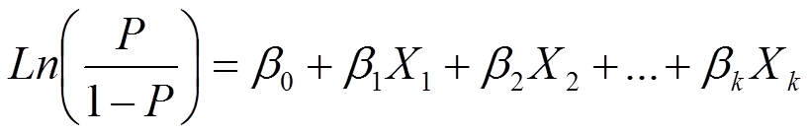

where,  
P is the probability of success or event of interest  
(P/1-P) is the odds  
X are independent variables  
β are coefficients of the independent variables (change in log odds per unit change in X)  
For this project, logistic regression model will be built in R using the glm() function and the summary of the model will be used for study of machine bias in race, sex and age category.  
  
Cox Proportional Hazard Model:  
Survival analysis corresponds to a set of statistical approaches used to investigate the time it takes for an event of interest to occur. Survival analysis is used in a variety of fields such as:  
- Cancer studies for patients survival time analyses  
- Sociology for “event-history analysis”  
- Engineering for “failure-time analysis”  
  
Most survival analyses use the following methods:  
i. Kaplan-Meier curves for visualizing survival rates over time  
The Kaplan-Meier (KM) method is a non-parametric method used to estimate the survival probability from observed survival times (Kaplan and Meier, 1958). The survival probability at time *ti*, *S*(*ti*), is calculated as follow:  
  


The estimated probability is a step function that changes value only at the time of each event and it is also possible to compute the confidence intervals for the survival probability. The KM survival curve, a plot of the KM survival probability against time, provides a useful summary of the data that can be used to estimate measures such as median survival time.  
  
ii. Log-rank test for comparing the survival curves of two or more groups  
The log-rank test is the most widely used method for comparing two or more survival curves. The null hypothesis is that there is no difference in survival between the two groups. The log-rank test is a non-parametric test, which makes no assumptions about the survival distributions. Essentially, the log-rank test compares the observed number of events in each group to what would be expected if the null hypothesis were true (i.e., if the survival curves were identical). The log-rank statistic is approximately distributed as a chi-square test statistic.  
  
iii. Cox proportional hazard regression for describing the effects of variables on survival  
The Cox proportional hazard model (Cox, 1972) is essentially a regression model commonly used statistical in medical research for investigating the association between the survival time of patients and one or more predictor variables. The Kaplan-Meier curves and log-rank tests are examples of univariate analysis. They describe the survival according to one factor under investigation but ignore the impact of any others.  
Additionally, Kaplan-Meier curves and log-rank tests are useful only when the predictor variable is categorical (e.g.: treatment A vs treatment B; males vs females). They don’t work easily for quantitative predictors such as gene expression, weight, or age. An alternative method is the Cox proportional hazard regression analysis, which works for both quantitative and categorical variables. Furthermore, the Cox regression model extends survival analysis methods to assess simultaneously the effect of several risk factors on survival time.  
The purpose of the model is to evaluate simultaneously the effect of several factors on survival. In other words, it allows us to examine how specified factors influence the rate of a particular event happening (e.g., infection, death) at a particular point in time. This rate is commonly referred as the hazard rate. Predictor variables (or factors) are usually termed covariates in the survival-analysis literature. The Cox model is expressed by the hazard function denoted by *h*(*t*). Briefly, the hazard function can be interpreted as the risk of dying at time *t*. It can be estimated as follows:



The Cox model can be written as a multiple linear regression of the logarithm of the hazard on the variables, with the baseline hazard being an ‘intercept’ term that varies with time.

The quantities *exp(bi)* are called hazard ratios (HR). A value of *bi* greater than zero, or equivalently a hazard ratio greater than one, indicates that as the value of the *i-th* covariate increases, the event hazard increases and thus the length of survival decreases. Put another way, a hazard ratio above 1 indicates a covariate that is positively associated with the event probability, and thus negatively associated with the length of survival. In summary,  
HR = 1: No effect  
HR < 1: Reduction in the hazard  
HR > 1: Increase in Hazard

In this project, since several factors (race, sex and age etc.) will be considered, cox proportional hazard regression models will be built by using the ‘survival’ library in R. In addition, as an analogy, a criminal defendant is “at risk” from the day he or she was given a COMPAS score, and that criminal defendant is considered “survive” if he or she did not recidivate within two years. Otherwise “not survive” if he or she did recidivate within two years.

5. Visualization:  
For data visualization of this project, common libraries in R, such as ggplot2, ggfortify, grid and gridExtra are utilized.   
  
6. Decision:  
Decisions made at the relevant sections of this project are to be based on the findings obtained from data exploration, visualization, and analysis.

1. Task 1: Task Summary (IRAC)  
   IRAC is an acronym that stands for Issue, Rule, Application, and Conclusion. It is a four-step process, and it is commonly used for analyzing legal issues. This method of legal analysis provides a standardized process for legal scholars and professionals to reach logical conclusions in both written and verbal arguments based on the law and the facts presented in cases. Below is a brief explanation of each part of the acronym:  
     
   Issue: Determine the important legal problem being presented in a case  
   Rule: Provide a detailed explanation of the relevant laws or legal rules raised by the issue  
   Application: Apply the identified laws or legal rules to the facts of the case  
   Conclusion: Formulate a reasonable conclusion and offer a final answer to the issue presented  
     
   As per the scenario of this project, the County Jailhouse in State Z in the United States is working on reducing recidivism and in order to achieve this objective, a new algorithm which will be used to predict the likelihood of recidivism of current inmates will be developed and the new algorithm will make use of feature variables such as race, gender and age. However, using feature variables such as race, gender and age may raise legal and ethical issue since US Federal Laws prohibit discrimination based on a person’s national origin, race, color, religion, disability, sex, age and familial status. This means people cannot be denied equal opportunity because of their race, gender and age etc. Hence, it may raise legal and ethical issues if feature variables such as race, gender and age are used for the algorithm and worse, the algorithm may be biased against criminal defendants from certain race, gender and age group, which will put them in unfair situations.  
     
   In this project and as mentioned above, the algorithm of the model makes use of features such as race, sex and age group, and this may raise legal and ethical issues. To address this, IRAC is a suitable methodology since it can be used to draw a conclusion that involves legal and ethical issue that seems complicated to be solved. Moreover, it is the traditional method for analyzing legal problems that arise in any context, a time-tested problem-solving tool that can help us work logically for any legal issues and reach conclusions. Hence for this project, IRAC is a suitable method which can be used to:   
   1. Identify the legal issue for using the algorithm (Issue)  
   2. Check for relevant rule from the Authority (Rule)  
   3. How it can be applied in the scenario of this project (Application)  
   4. Make a conclusion (Conclusion)
2. Task 2: Read and prepare the data for Risk of Recidivism

- Import modules needed to implement predictive maintenance, R is used (ggplot and dplyr)

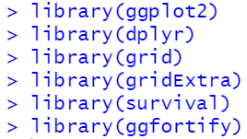

- Read the non violent dataset to read the number of rows

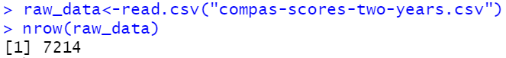

- Remove rows based on following conditions

o If the charge date of a defendants Compas scored crime was not within 30 days from when the person was arrested, we assume that because of data quality reasons, that we do not have the right offense.

o We coded the recidivist flag -- is_recid -- to be -1 if we could not find a compas case at all.

o In a similar vein, ordinary traffic offenses -- those with a c_charge_degree of 'O' -- will not result in Jail time are removed (only two of them).

o We filtered the underlying data from Broward county to include only those rows representing people who had either recidivated in two years, or had at least two years outside of a correctional facility.

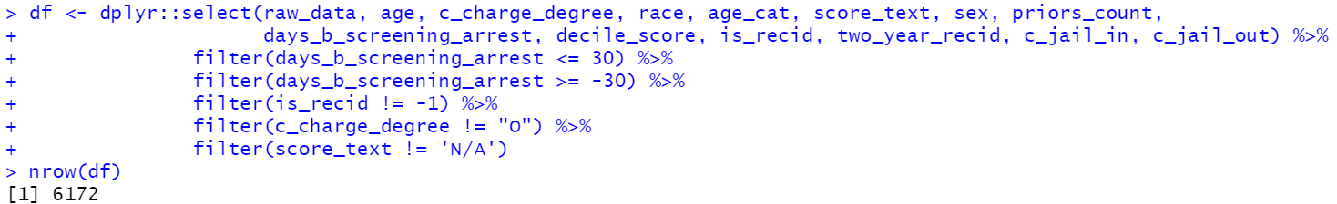

- Get new filed longer length of stay



- Get the summary of race, gender, age, xtabs by sex and race

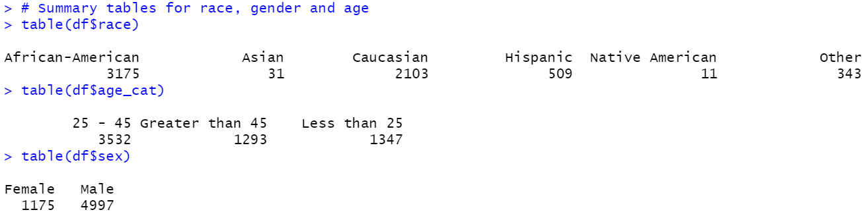

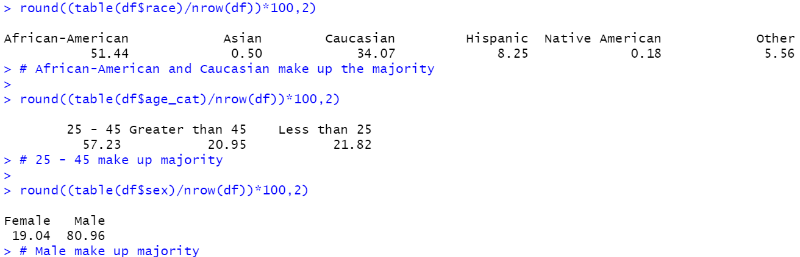

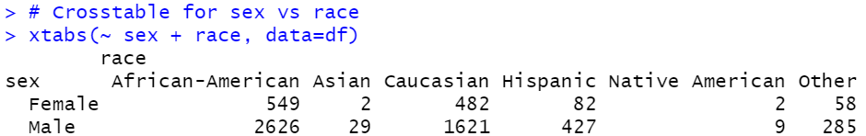

- Plot the data with race and decile score

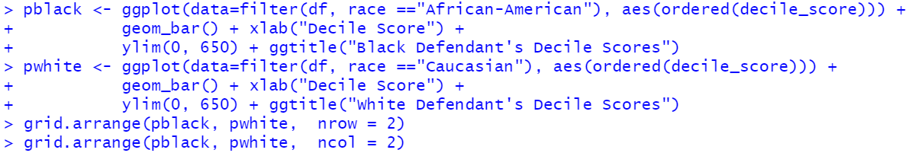

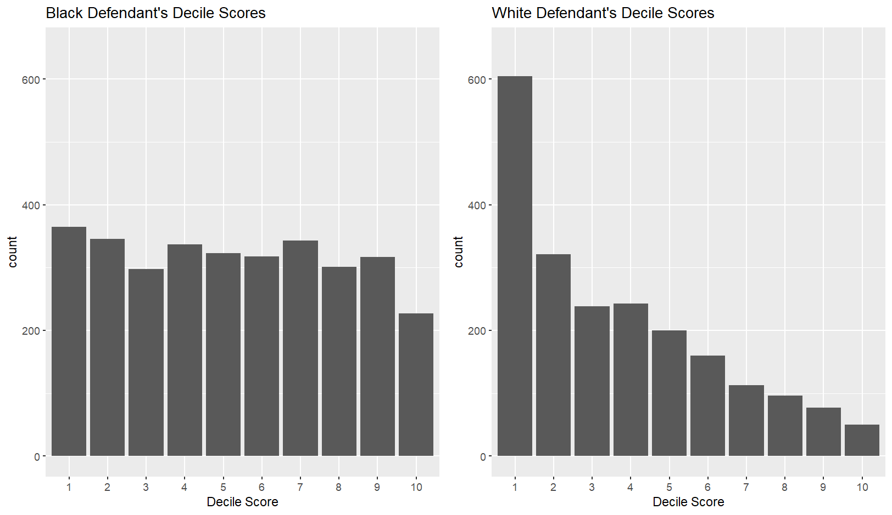



1. Screen-shots of each task of Task 3 (Predict racial Bias)  
   - Change some variables (age, race, gender) into factors, and run a logistic regression, comparing low scores to high scores.

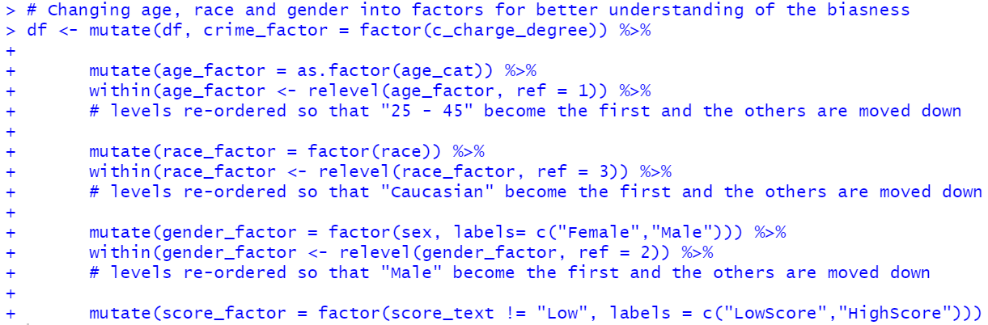

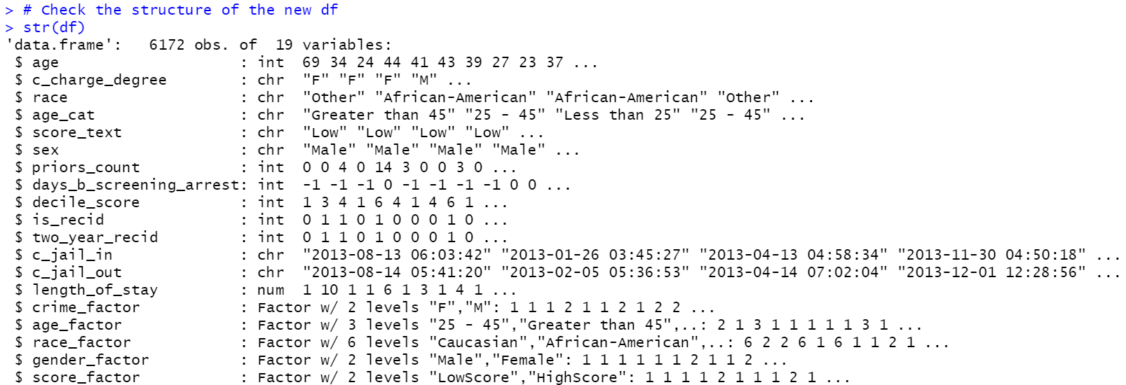

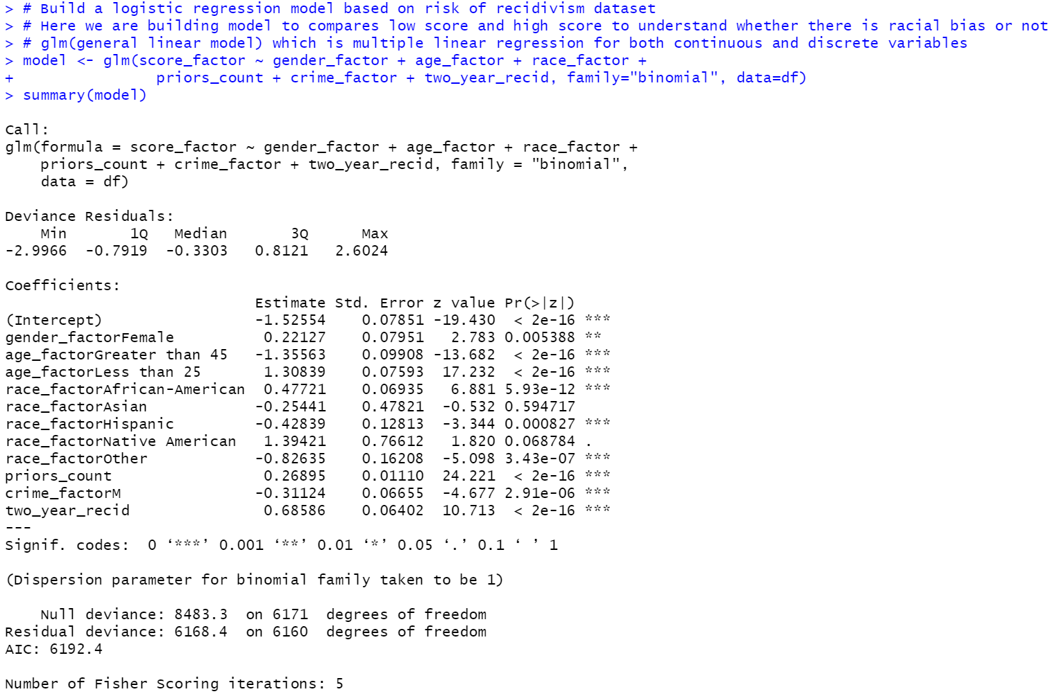



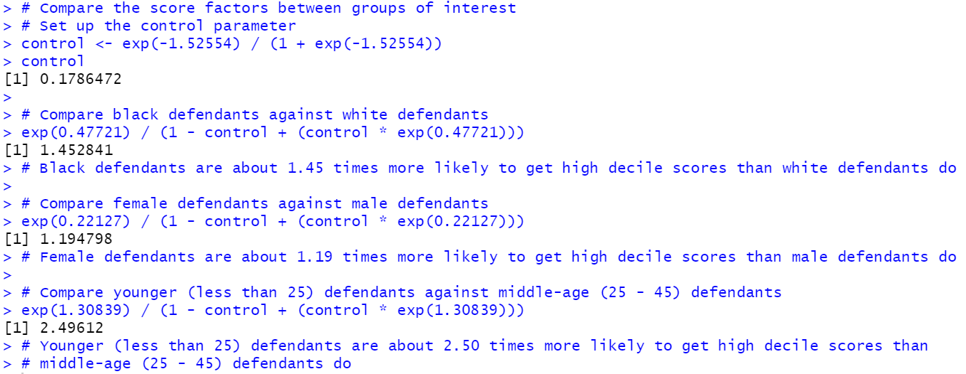

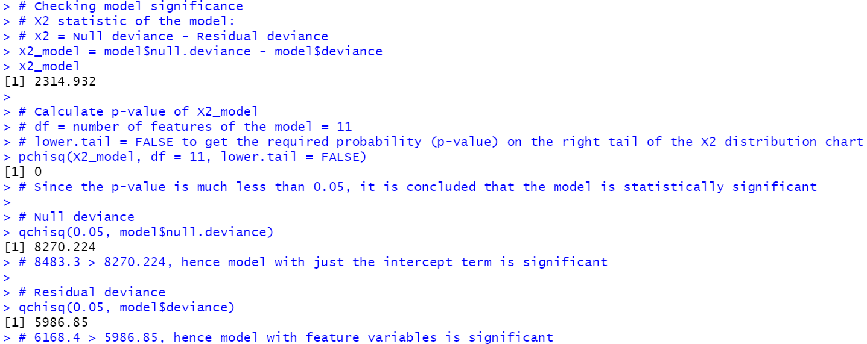

1. Screen-shots of each task of Task 4 (Read and prepare the data for Risk of Violent Recidivism)

- Read the violent dataset to read the number of rows



- Remove rows based on following conditions

o If the charge date of a defendants Compas scored crime was not within 30 days from when the person was arrested, we assume that because of data quality reasons, that we do not have the right offense.

o We coded the recidivist flag -- is_recid -- to be -1 if we could not find a compas case at all.

o In a similar vein, ordinary traffic offenses -- those with a c_charge_degree of 'O' -- will not result in Jail time are removed (only two of them).

o We filtered the underlying data from Broward county to include only those rows representing people who had either recidivated in two years, or had at least two years outside of a correctional facility.

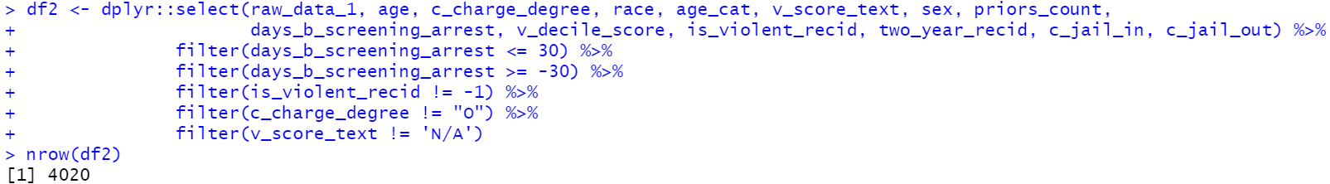

- Get new filed longer length of stay



- Get the summary of race, age category

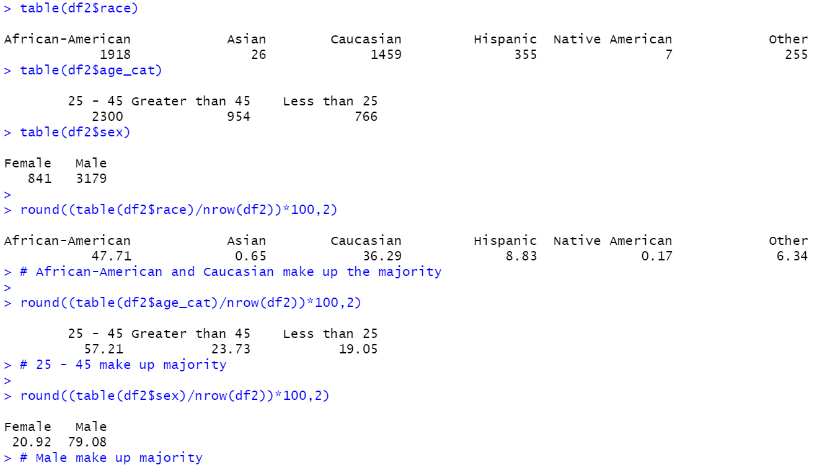

- Plot the data with race and decile score

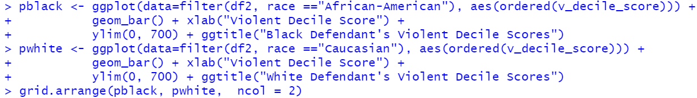

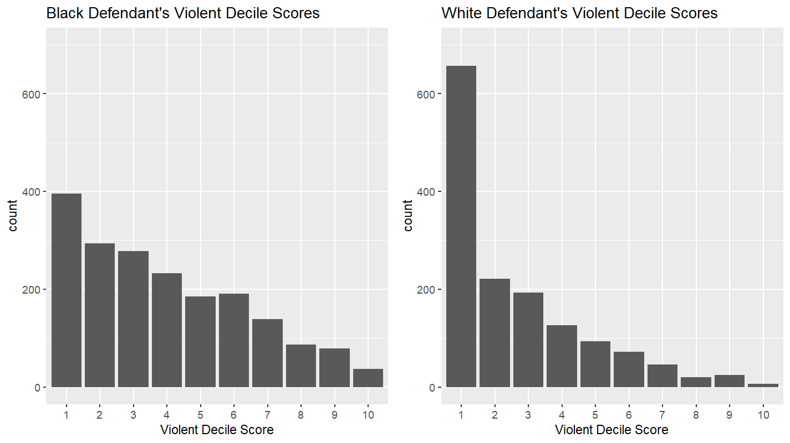



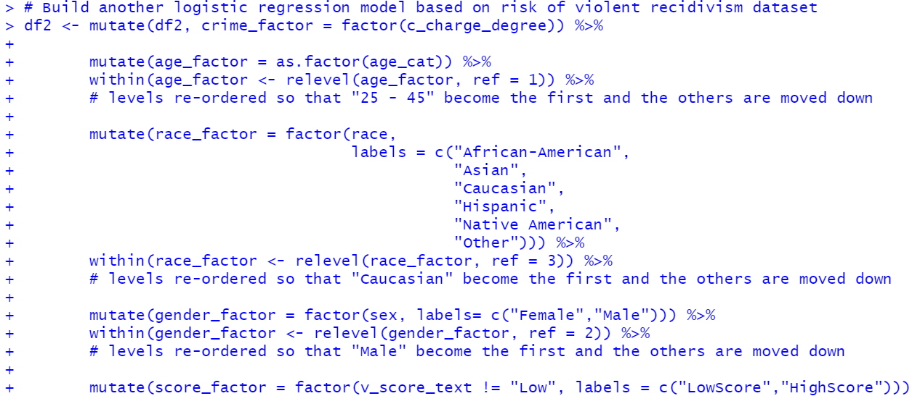

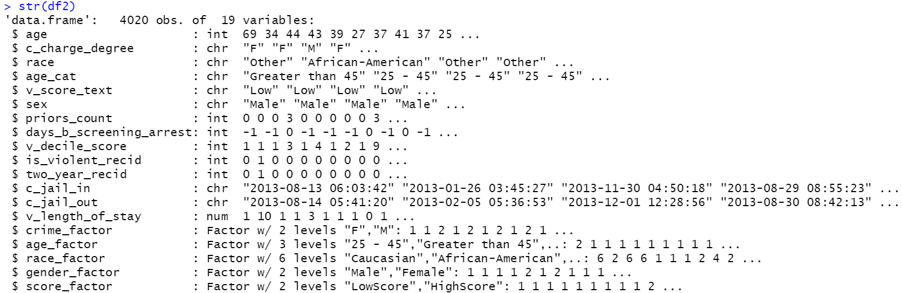

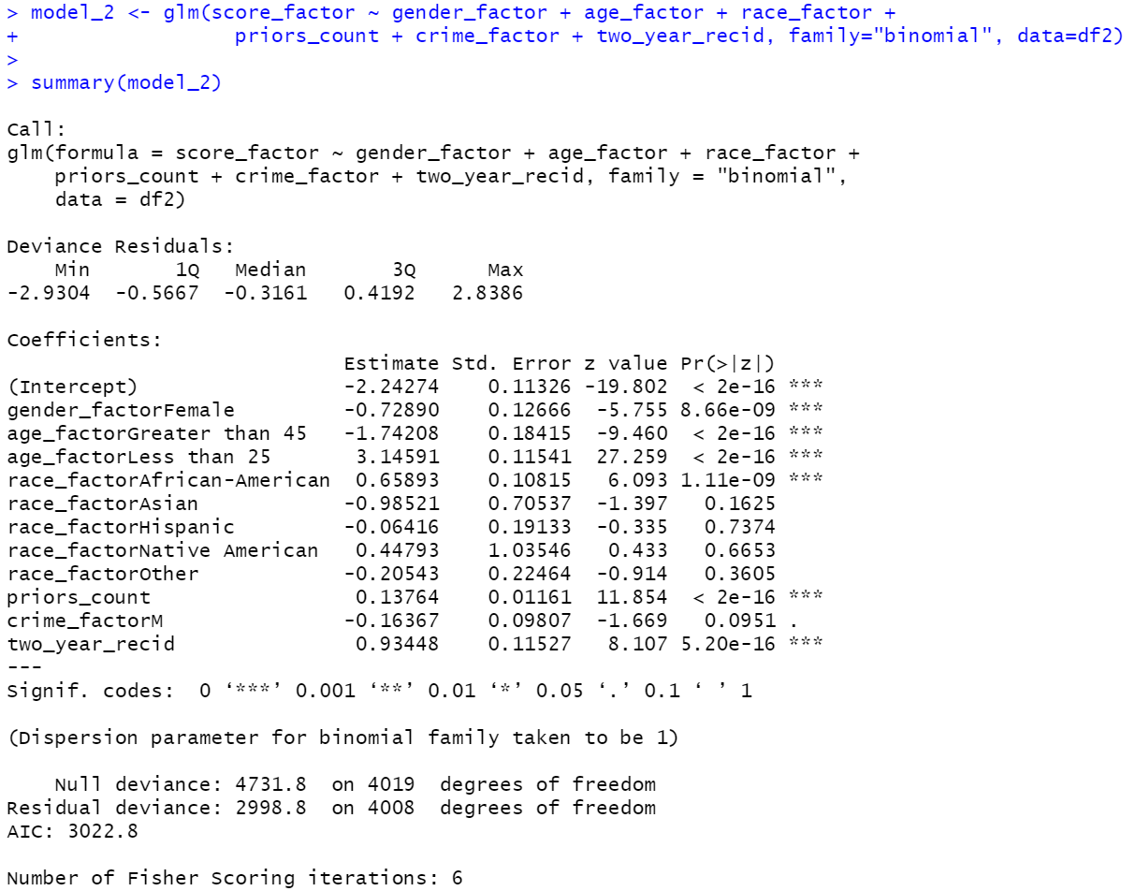



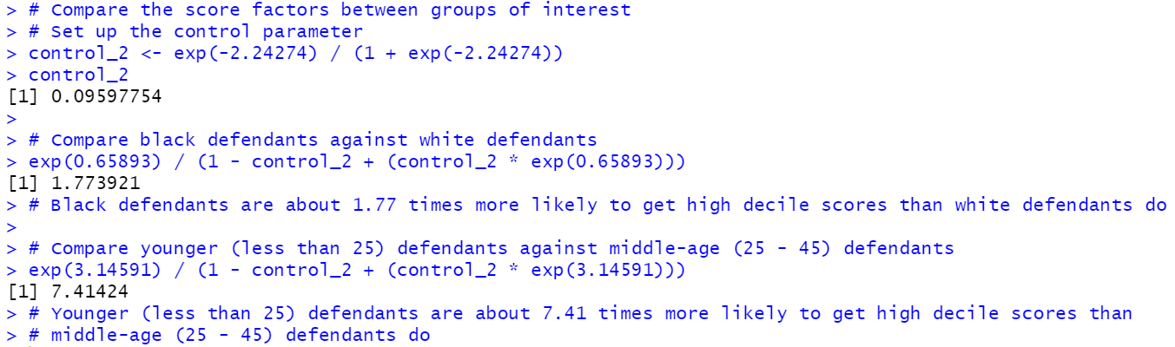

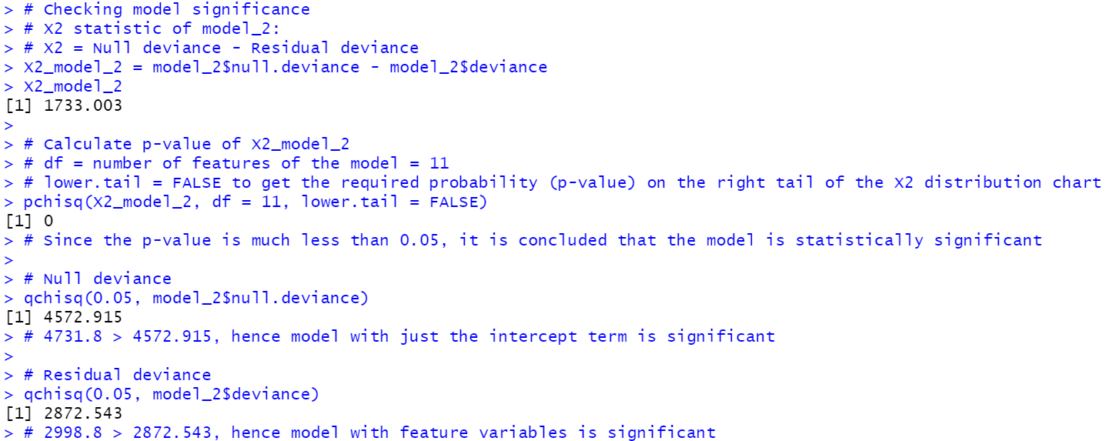

1. Screen-shots of each task of Task 5 (Predict accuracy)



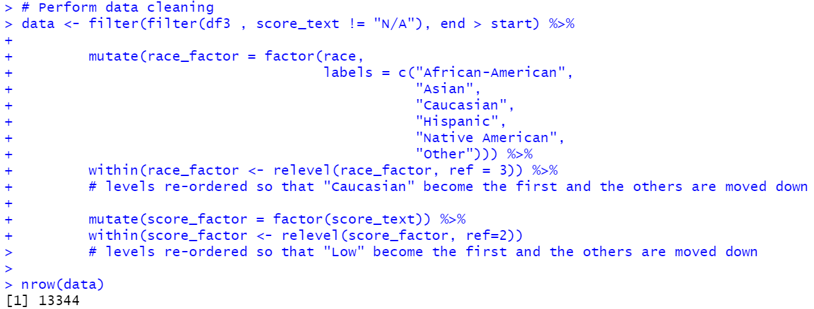

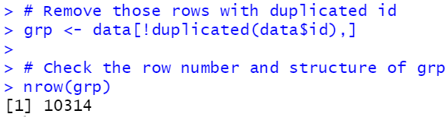

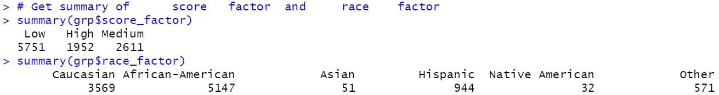

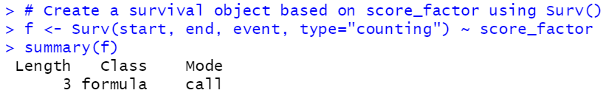

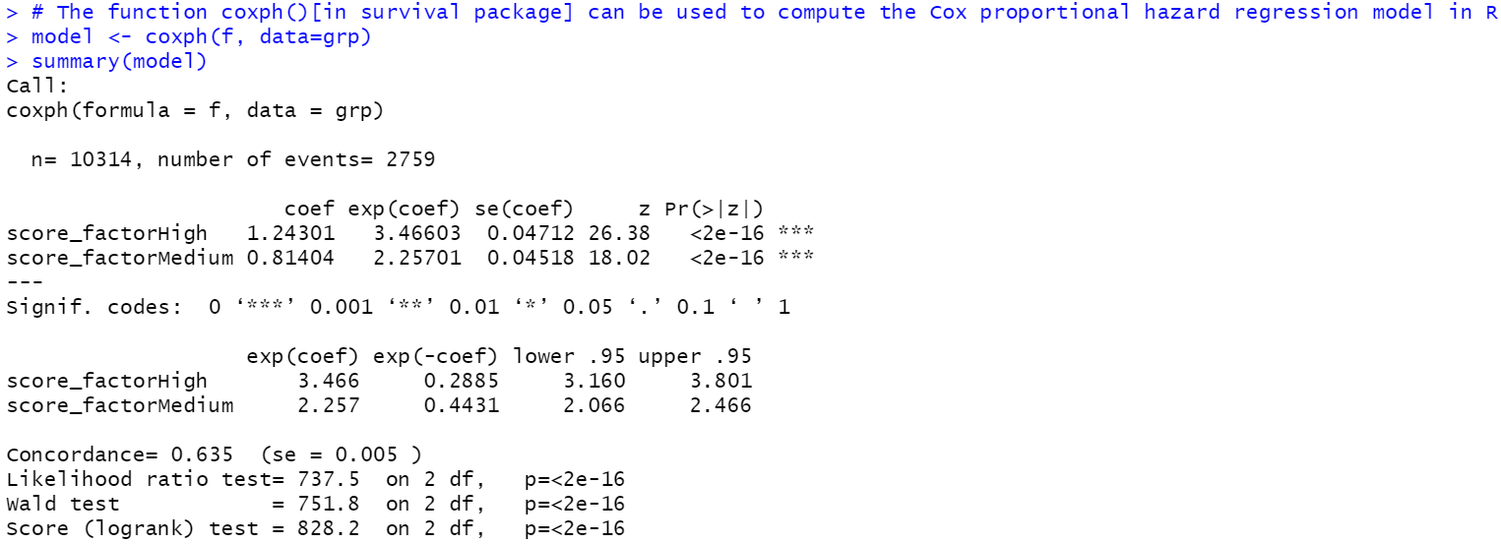

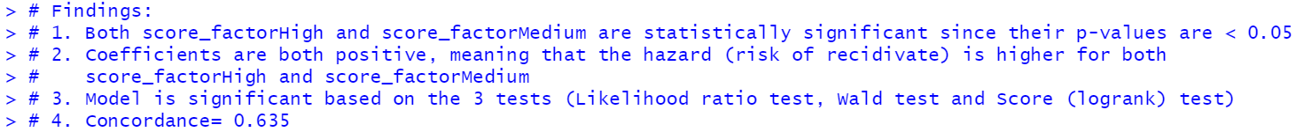

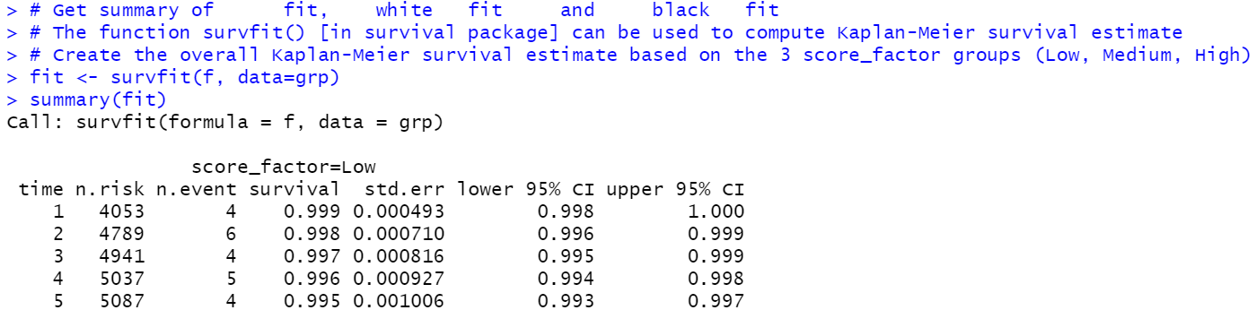

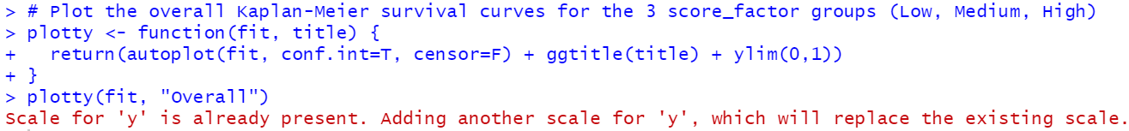

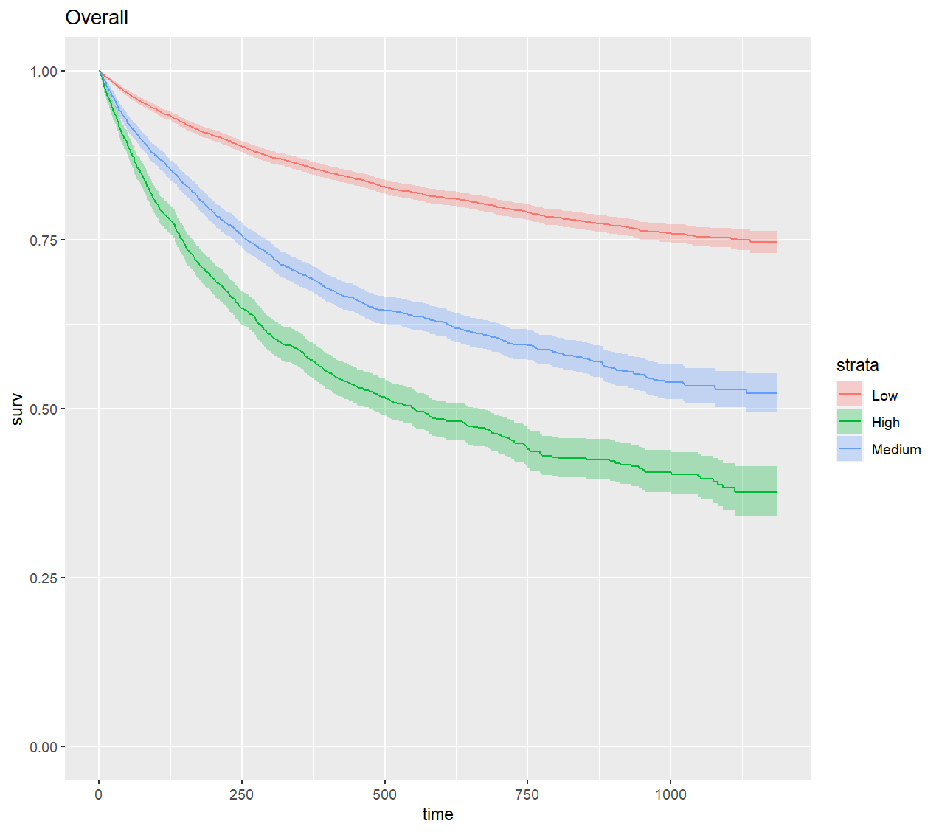



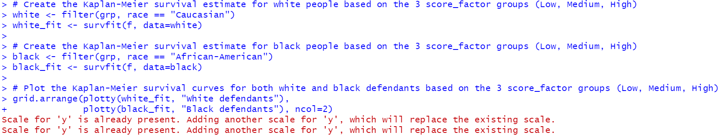

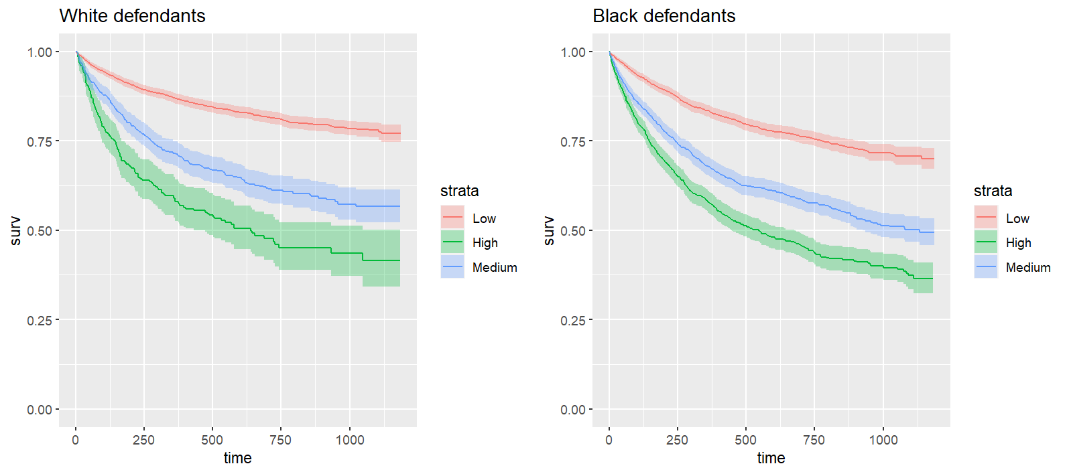



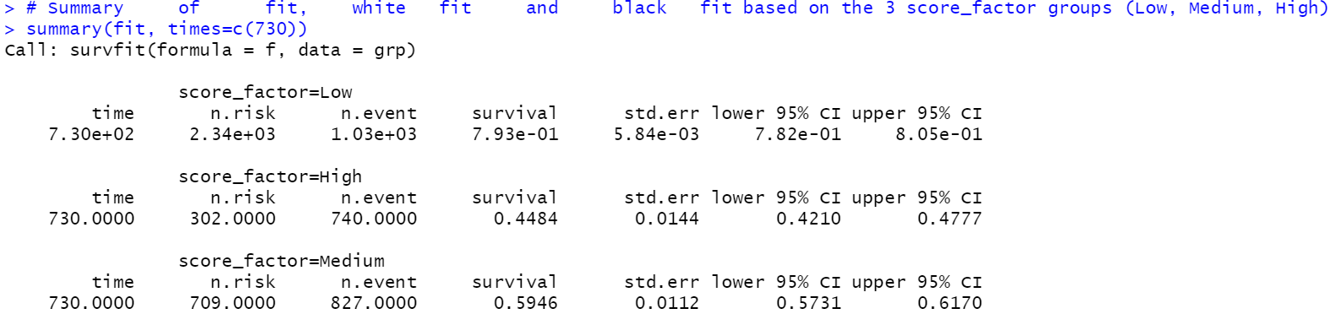

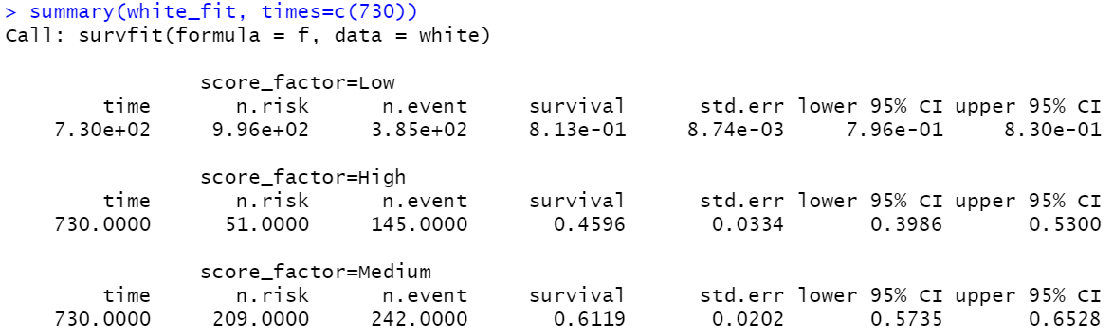

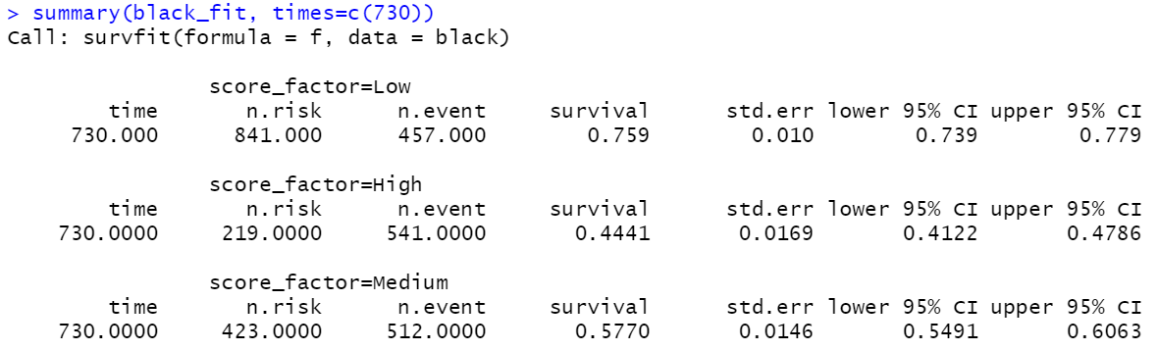

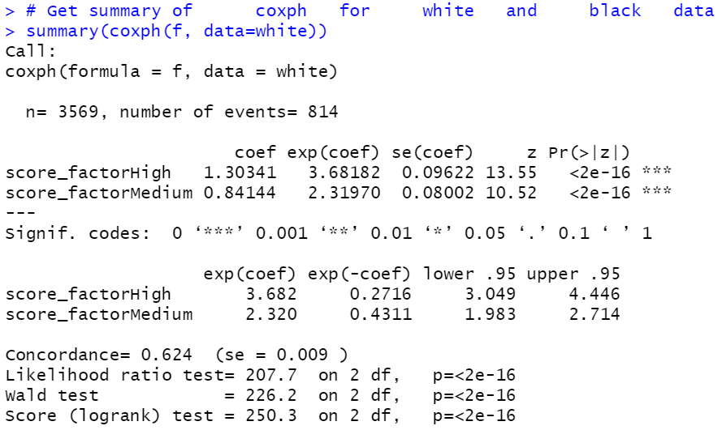

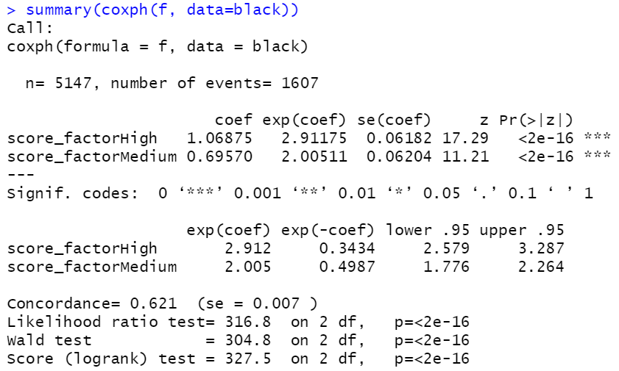

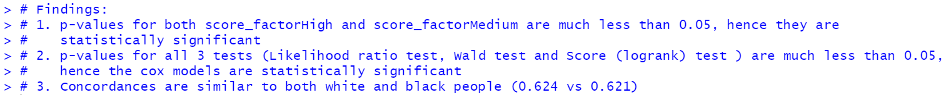

1. Screen-shots of each task of Task 6 (Directions of racial bias)



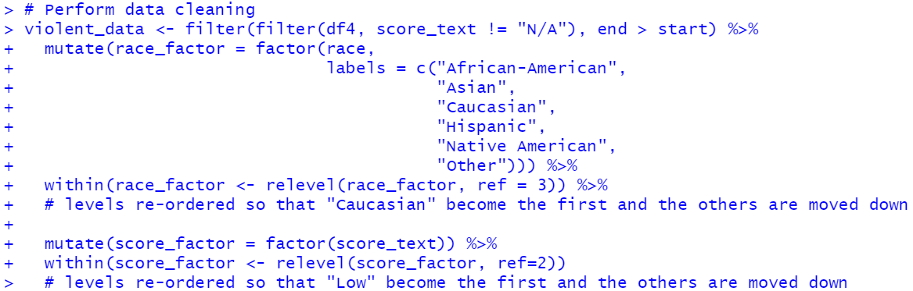

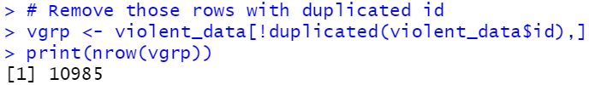



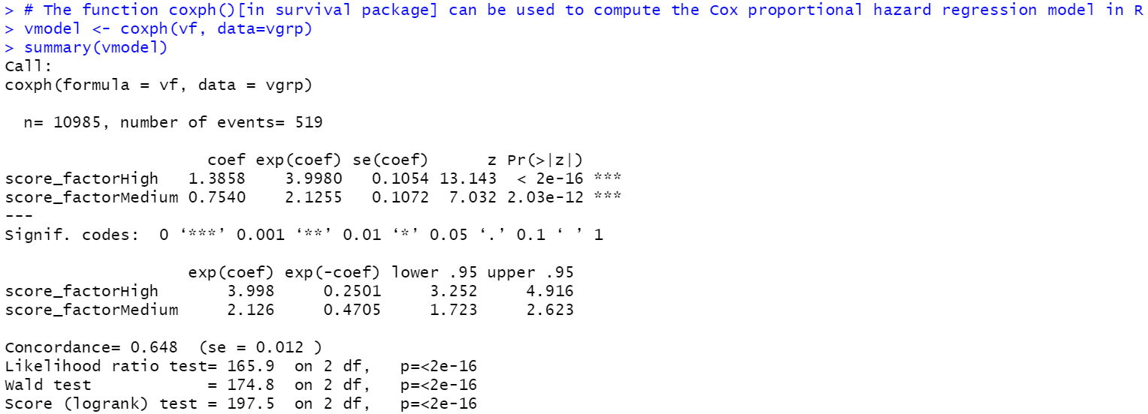

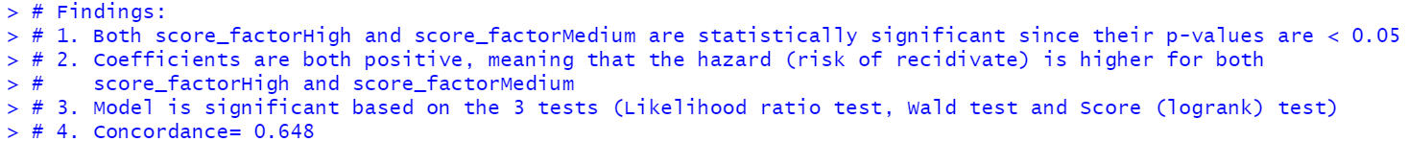

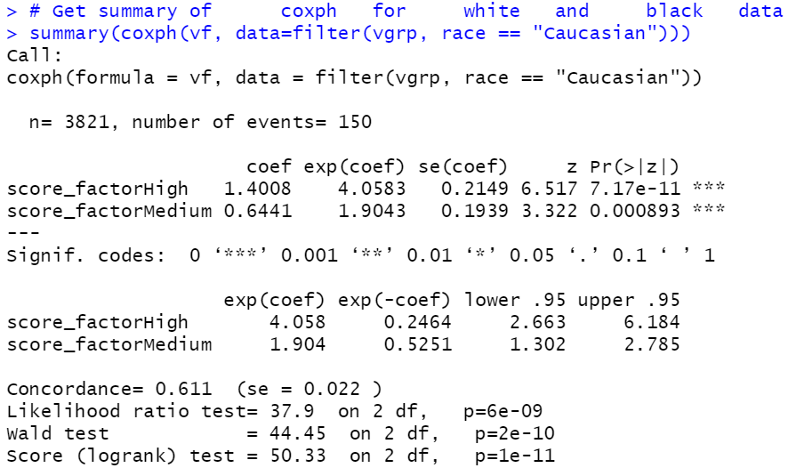

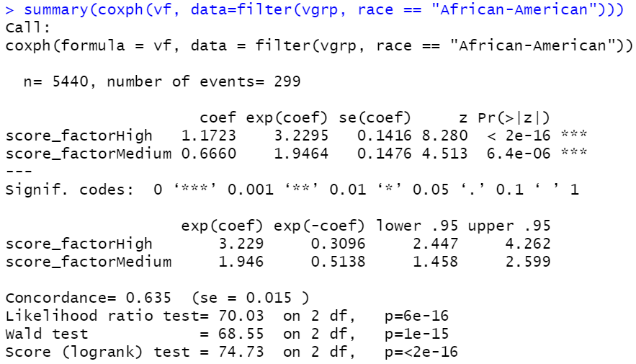

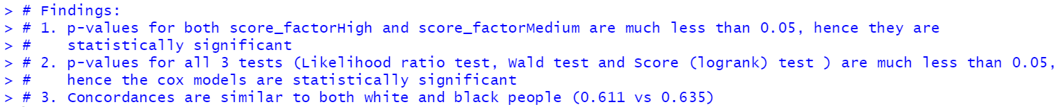

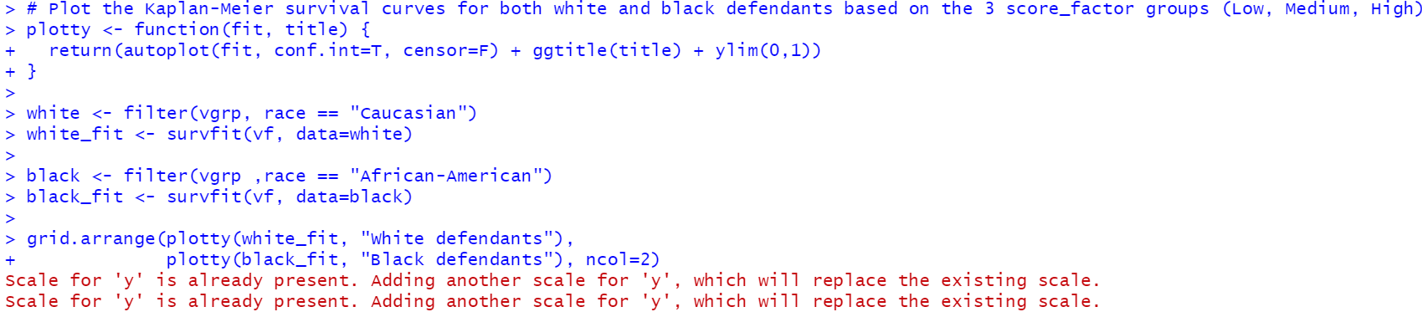

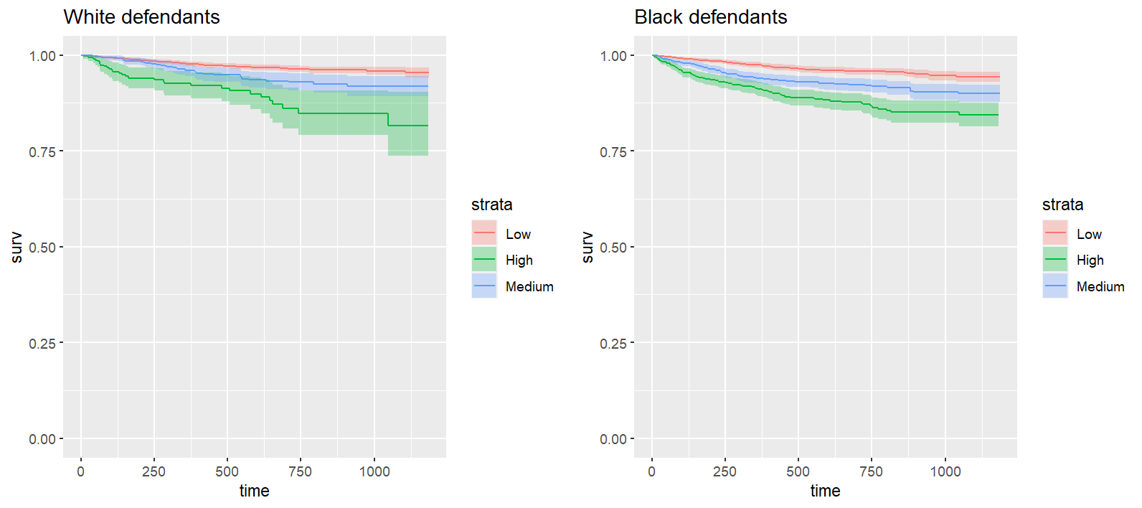



1. Screen-shots of each task of Task 7 (Directions of gender bias)

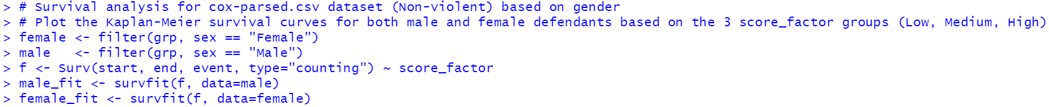

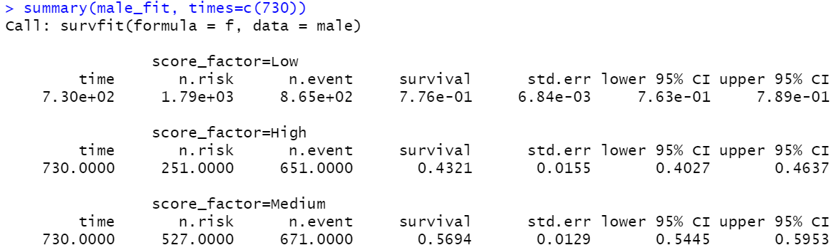

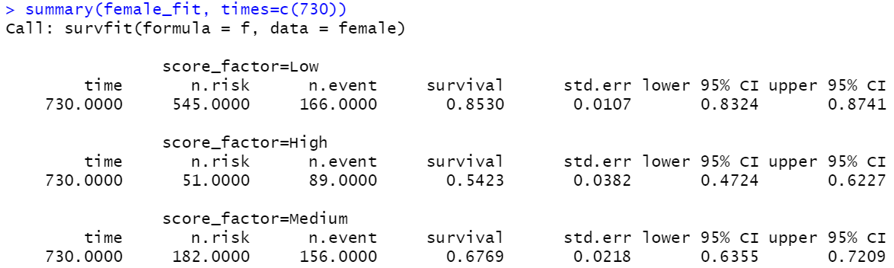



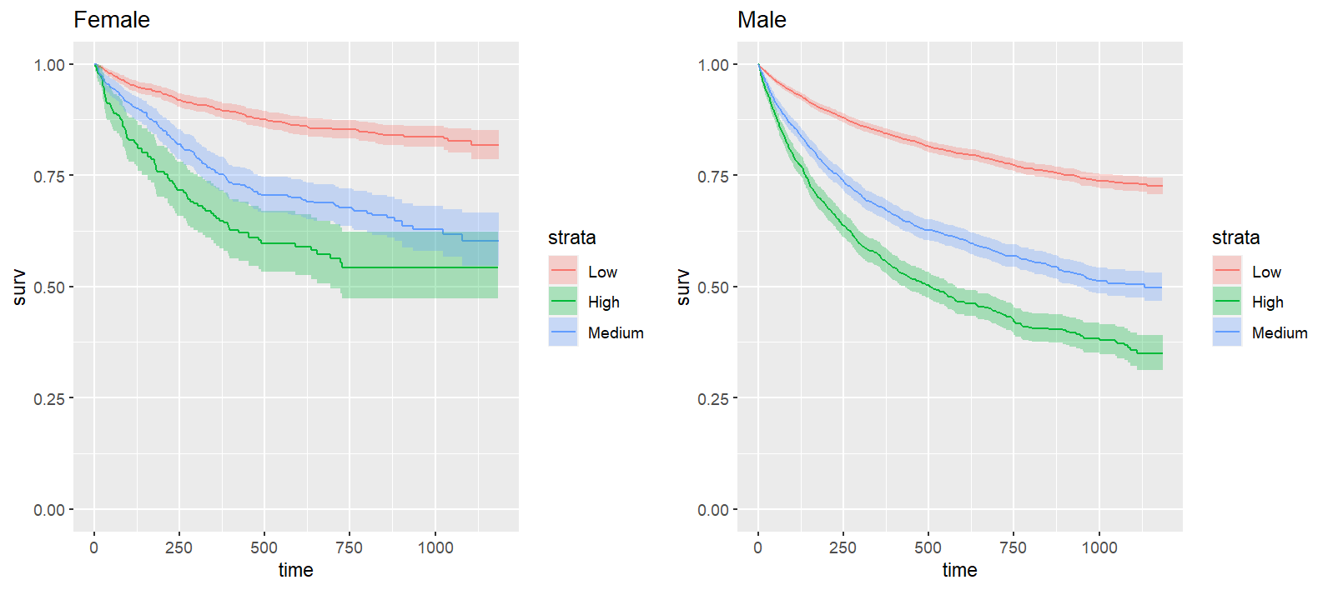

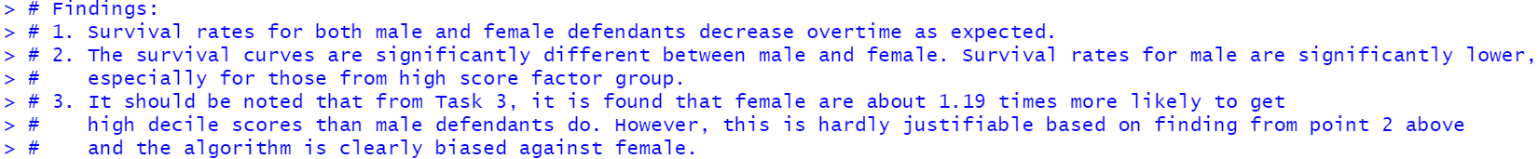

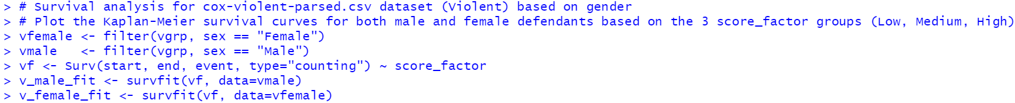

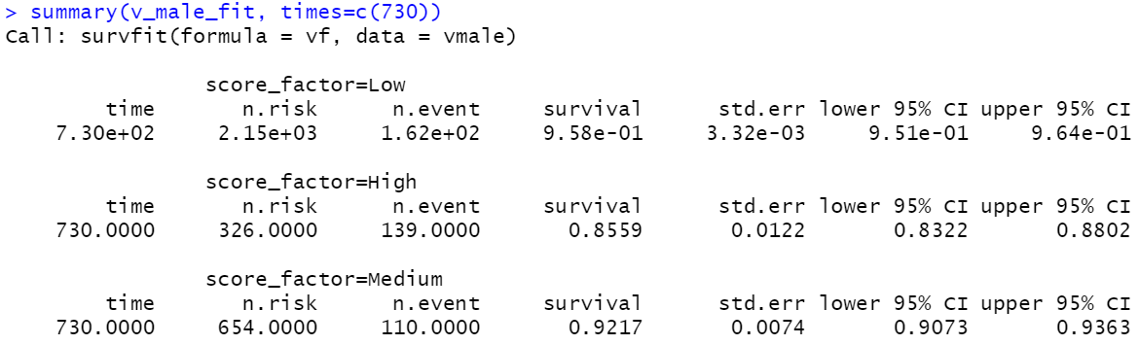

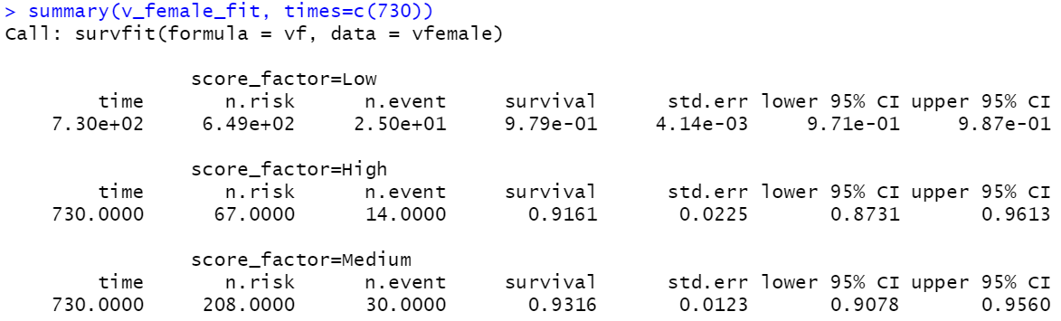



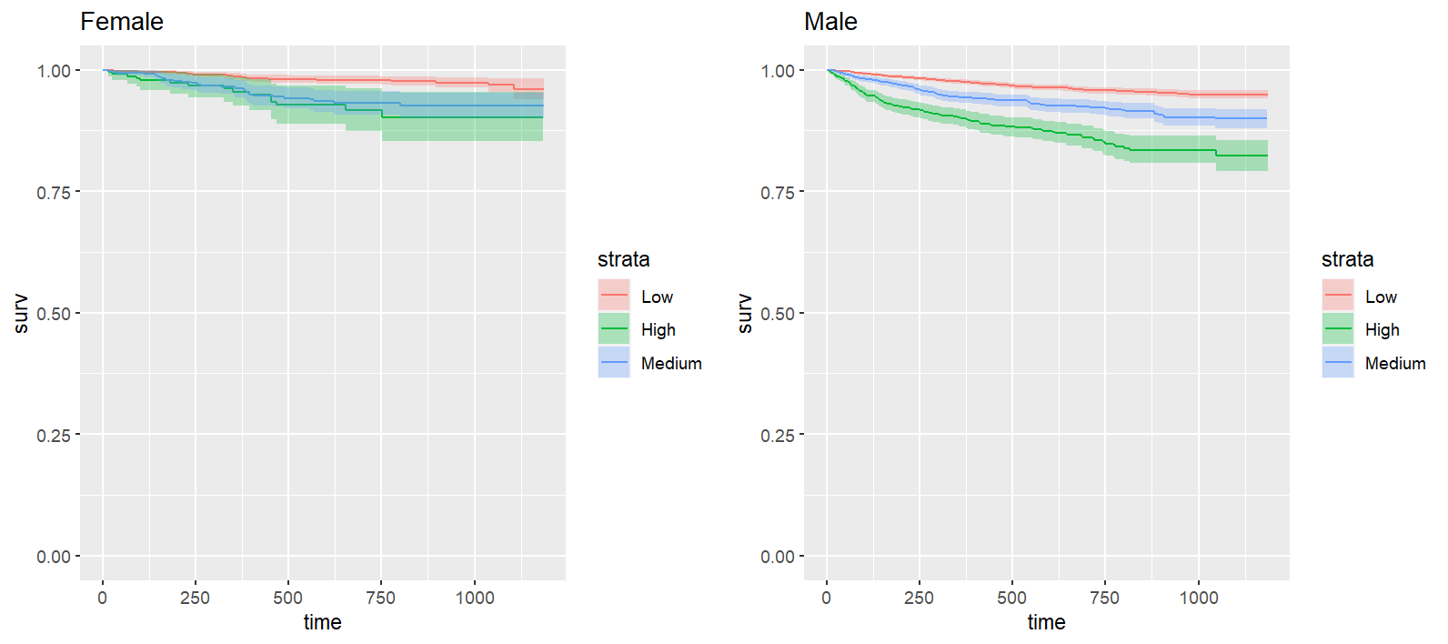



1. IRAC Method for Addressing Legal Issue Using Sentencing Software

**Scenario**

The County Jailhouse in State Z in the United States is working on reducing recidivism, which is the tendency of a convicted criminal to reoffend. In order to accomplish their objective, the Jailhouse hired a data scientist to design an algorithm to predict the likelihood of recidivism of current inmates. The data inputs for this new algorithm include variables such as age, prior convictions, race and gender. The Jailhouse will use the predictions to determine whether or not to release inmates who come up for parole, or to grant early release from their sentence.

One of the Jailhouse employees shared the plans to use the new algorithm with a friend who is an attorney at a local non-profit justice organization. In response to the plans, the organization filed a lawsuit against State Z to prevent the Jailhouse from using the algorithm for parole decisions. State Z and the Jailhouse are contesting this lawsuit and want to move forward with use of the algorithm.

**Issue**  
Under US Federal Laws, is it lawful to use an algorithm which incorporates the use of race and gender for predicting recidivism?

**Rule**  
In 1964, US Congress passed Public Law 88-352 (78 Stat. 241). The Civil Rights Act of 1964 prohibits discrimination on the basis of race, color, religion, sex or national origin. Provisions of this civil rights act forbade discrimination on the basis of sex, as well as, race in hiring, promoting, and firing. The Act prohibited discrimination in public accommodations and federally funded programs. It also strengthened the enforcement of voting rights and the desegregation of schools.  
This act also protects individuals from government actions which infringe on civil and human rights.

Reference:

<https://www.dol.gov/agencies/oasam/civil-rights-center/statutes/civil-rights-act-of-1964#:~:text=In%201964%2C%20Congress%20passed%20Public,hiring%2C%20promoting%2C%20and%20firing>.

**Application**  
In our case here, it is clear that the purpose of State Z for using this algorithm is to reduce recidivism, which is undoubtedly lawful. However, since the algorithm incorporates the use of features such as race and sex, and these are protected classifications, so their use in the algorithm shall require scrutiny. State Z shall prove that there are absolutely no other substitutions which can be used to replace those protected classifications in order to predict recidivism, since classifying whether a criminal defendant is of high risk of recidivating based on race and gender is an act of discrimination, and it is clearly unlawful under Civil Rights Act of 1964.

**Conclusion**  
Since State Z has no proof that incorporating those protected classifications (race, sex) is the only possible way to predict recidivism of County Jailhouse inmates, it is concluded that the use of these protected classifications is a violation of inmate rights and unlawful under the Civil Right Act of 1964. The County Jailhouse in State Z shall not be permitted to use the algorithm with those protected classifications for predicting recidivism and parole decisions.

1. Conclusion  
   In this project, it is demonstrated that in the field of data science, when working on a machine learning algorithm, data scientists should not be only focusing on data acquisition, data cleaning, machine learning model building and its accuracy. We should also be cautious about those selected features used in the machine learning algorithm, since those selected feature (such as race, sex etc.) may incur ethical and legal issues if they are used in the algorithm and not justified properly. Those feature variables, if used in the machine learning algorithm, may inherently be biased against certain group of people (eg. black defendants in this project), which may eventually put them in unfair situations, and this is unethical and/or unlawful.  
   In this era of big data, the data generated every day are at unprecedented rates. Data is almost everywhere, be it in the government bodies, big and small corporations, or personal usage, it shall be emphasized that data shall be used in ethical and lawful ways. While the modern society can enjoy the benefits of utilizing big data, we should also be aware that data can be a double-edged sword, since any mishandling of the data, be it knowingly or unknowingly, may risk of harming certain group of people in the society in unethical and/or unlawful ways.
2. Annexure 1  
   -Datasets for the project  
     
      
     
   - R codes

